Artemisinin
Artemisinin, also called qinghaosu (China) is an antimalarial drug derived from the sweet wormwood plant, Artemisia annua. Artemisinin is effective against all the malaria-causing protozoal organisms in the genus Plasmodium. The drug is particularly useful in the treatment of infections involving chloroquine-resistant parasites and infections involving multidrug-resistant P. falciparum, which is the deadliest of the malaria protozoans.
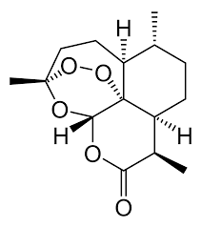
Artemisinin is a sesquiterpene lactone containing an unusual peroxide bridge. This endoperoxide 1,2,4-trioxane ring is responsible for the drug's mechanism of action.
Derivatives of artemisinin such as artesunate, artemether etc. also have potent activity against Plasmodium falciparum.
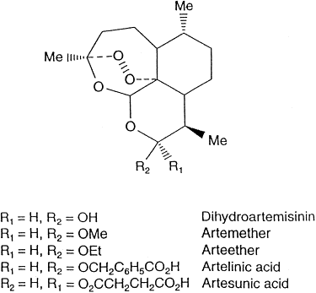

ACT = Artemisinin combination therapies
Artemether-lumefantrine ACTs recommended by the WHO
Artesunate+amodiaquine for treatment of uncomplicated
Artesunate+mefloquine malaria
Artesunate+sulfadoxine-pyrimethamine

Biosynthesis of Artemisinin
Students*** study only MVA path way not MEP path way
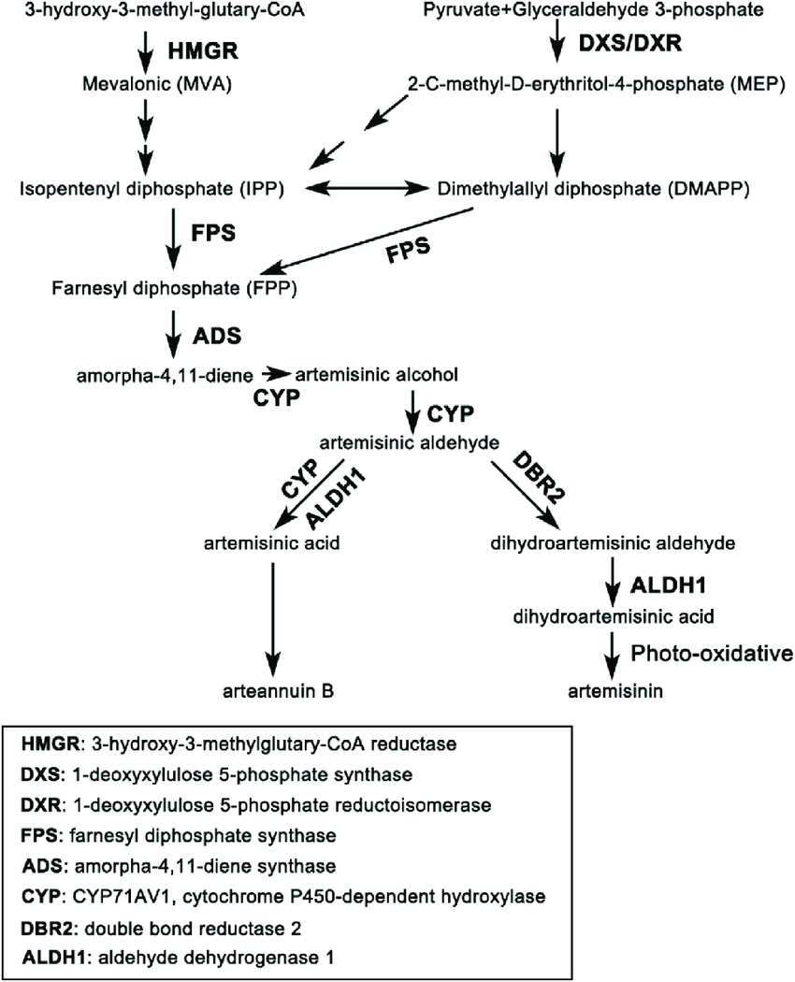
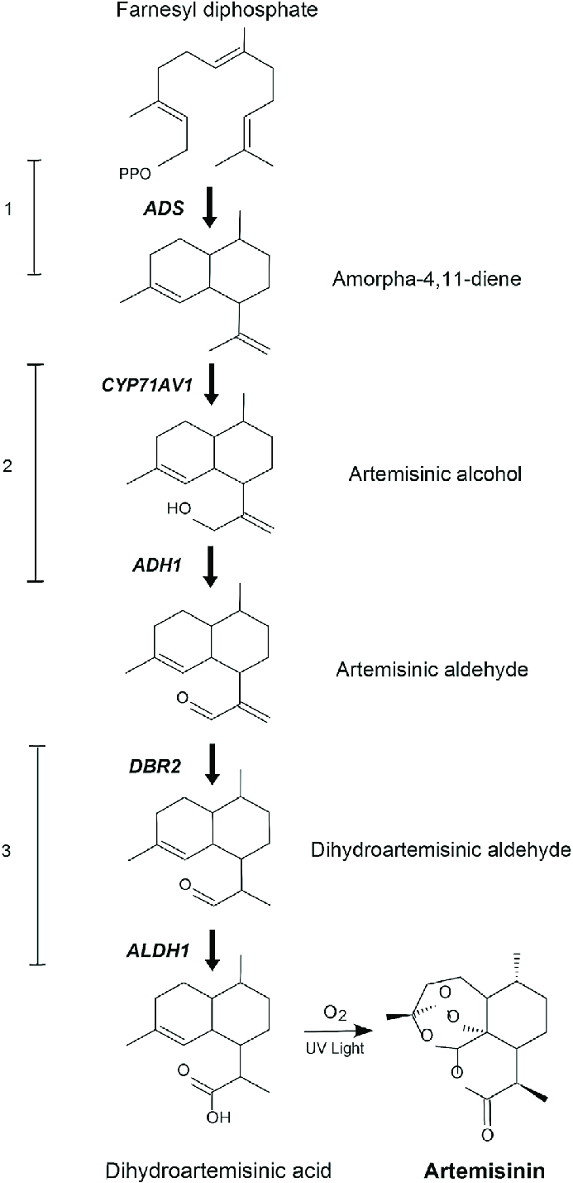

Mechanism of Action
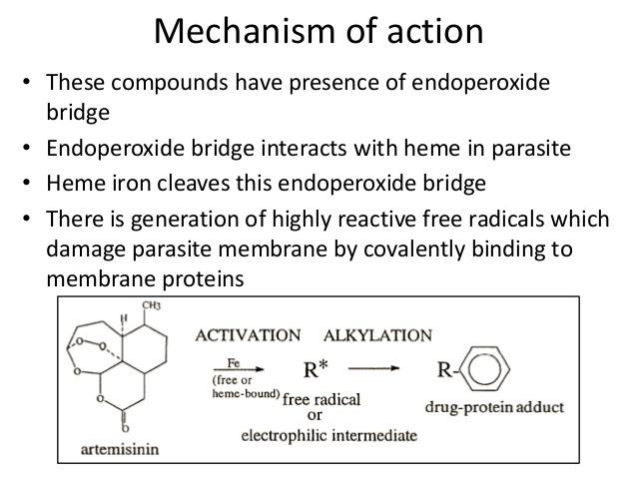
Synthesis of Artemisinin
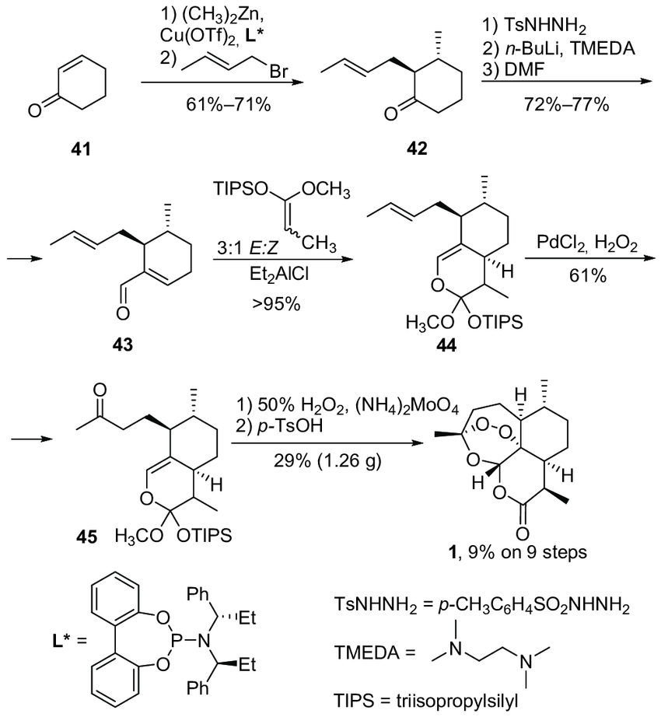
More about Artemisinin on websites:
Pl. view the slide show at the following site:
https://www.slideshare.net/saptarshisamajdar/artemisinin-72509028

