Azadirachtin
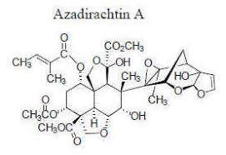
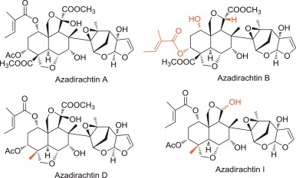
****Students: Remember only structure of Azadirachtin A
- Azadirachtin is a chemical compound belonging to the complex tetranortriterpenoid limonoid group and is extracted from fruit of Neem tree, Azadirachta indica.
- It contains 16 stereocenters and functional groups: an acetate ester, an epoxide, an enoate ester, a cyclic hemiketal, a tertiary alcohol, a secondary alcohol and a methyl ester.
- It is a secondary metabolite.
- It is found in bark, leaves and fruits of the tree but seeds have the highest concentration.
- In the extract 18 compounds have been identified among which salanine, meliantrol and azadiractin are most prominent, the latter being in the highest concentration.
- When the natural neem oil, extracted from the seeds, is treated with alcohol then almost all of the azadirachtin and related chemicals separate from the oil itself. The remaining oil is known as Clarified Hydrophobic Extract of Neem Oil.
Uses of Azadirachtin
- The ability of the oil to repel pests has been known for thousands of years

Azadirachtin action: It has both systemic and direct contact action. It deters certain insects, such as locusts, from feeding and it interferes with the normal life cycle of insects, including feeding, molting, mating, and egg laying. It is used as a commercial insect growth regulator that controls the metamorphosis process as the insect passes from the larva stage to the pupa stage. It reduces the level of the insect hormone Ecdysome by disrupting the insect's molting process so that the immature larvae cannot develop into adults.
- The oil also has been used on skin and medicinally.
- It has several other uses as shown in the following figs.

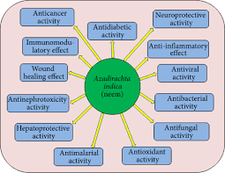
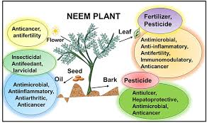
Biosynthesis of Azadirachtin A
Students : Consider synthesis of GPPS by MVA path way, ignore MEP pathway.
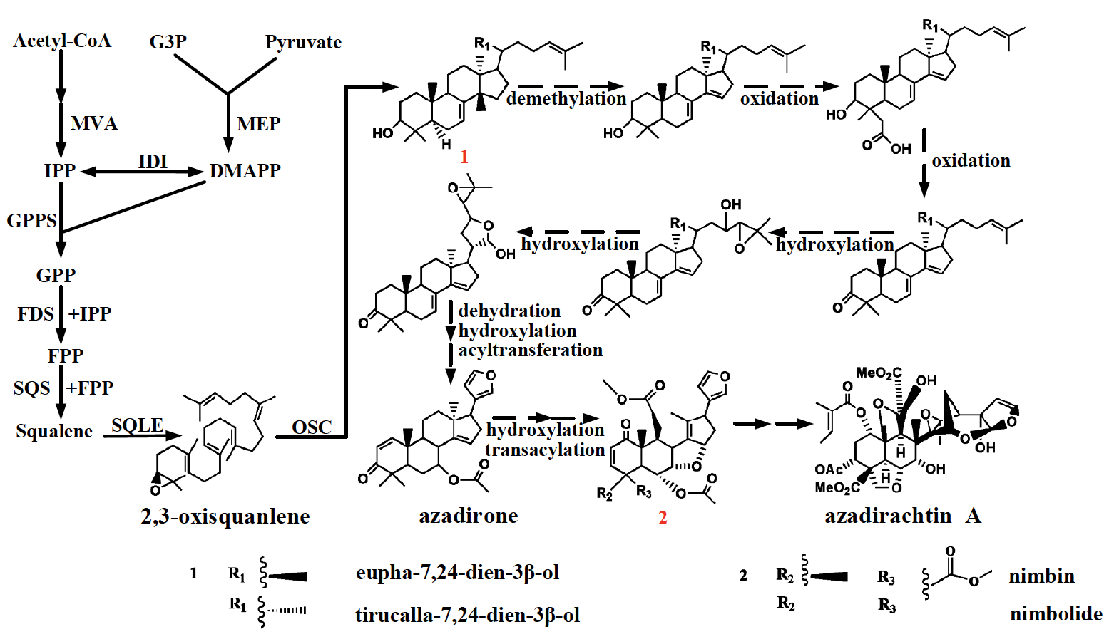

For more details see research paper

BMC Genomics

Huiyan Wang, Ning Wang, Yixin Huo

DOI: 10.21203/rs.2.23446/v1

Multi-tissue transcriptome analysis using hybrid-seq revealed potential genes and biological pathways associated with azadirachtin A biosynthesis in neem (Azadirachtin indica)

Total synthesis of Azadirachtin

The first total synthesis was completed by Steven Ley in 2007.

Synthesis of Azadirachtin: A Long but Successful Journey Veitch, GE; Beckmann, E.; Burke, BJ; Boyer, A.; Maslen, SL; Ley, SV .... Angew Chem Int Ed 2007 , 46 ., 7629 DOI:10.1002/Anie.200703027A Relay Route for the Synthesis of Azadirachtin Veitch, GE; Beckmann, E.; Burke, B. j;. Boyer, A.; Ayats, C.; Ley, SV ... Angew Chem Int Ed. 2007 , 46 ., 7633 DOI: 10.1002/Anie.200703027

Key step in the synthesis is shown below

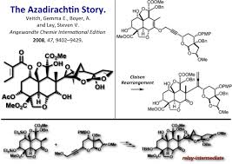

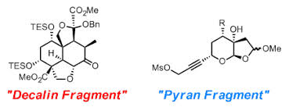

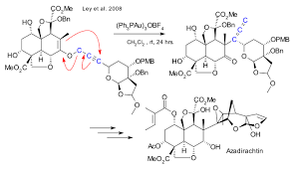
Propargylmesylat-Fragment

