2,3-Dichloro-5,6-Dicyanobenzoquinone (DDQ)

Part - 1
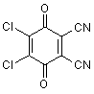
DDQ (2,3-dichloro-5,6-dicyanobenzoquinone), which is a stronger oxidant than 1,4-benzoquinone, is used as reagent for oxidative couplings and cyclization reactions and dehydrogenation of hydroaromatic compounds.
Applications of DDQ
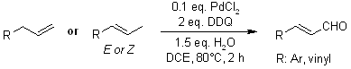
Palladium-catalyzed oxygenation of allyl arenes or alkenes produce (E)-alkenyl aldehydes with high yields. Allylic C-H bond cleavages occur under mild conditions during this process. Mechanistic studies show that oxygen source is water.
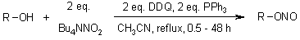
Alkyl nitrites were prepared in good to excellent yields by treatment of alcohols and thiols with triphenylphosphine/2,3-dichloro-5,6-dicyanobenzoquinone/Bu₄NNO₂ in acetonitrile. This method allows a selective conversion of primary alcohols in the presence of secondary and tertiary alcohols and thiols.
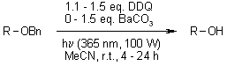
The deprotection of benzyl ethers was effectively realized in the presence of 2,3-dichloro-5,6-dicyano-p-benzoquinone (DDQ) in MeCN under photoirradiation using a long wavelength UV light.
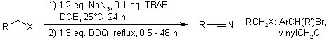
A tandem TBAB-catalyzed substitution and a subsequent novel oxidative rearrangement allow the synthesis of aryl or alkenyl nitriles from from benzyl and allyl halides. The broad reaction scope and the mild conditions may make these methods of use in organic synthesis.
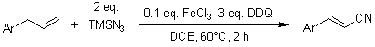
An inexpensive homogeneous iron catalyst enables a direct approach to alkenyl nitriles from allylarenes or alkenes. Three C-H bond cleavages occur under the mild conditions during this process, involving the cleavage of the allyl C(sp³)-H bond as the rate-determining step.
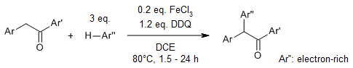
An iron-catalyzed oxidative dehydrogenation enables an α-arylation of deoxybenzoins with non-prefunctionalized arenes with broad substrate scope and functional group tolerance. The reaction provides efficient access to synthetically useful 1,2,2-triarylethanones.
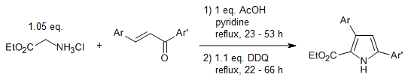
An electrocyclic ring closure is the key step of an efficient one-pot synthesis of pyrrole-2-carboxylates and -carboxamides from chalcones and glycine esters or amides. The resulting 3,4-dihydro-2H-pyrrole intermediates are oxizided to the corresponding pyrroles by stoichiometric oxidants or by catalytic copper(II) and air in good yields.
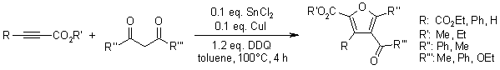
A reliable method for the direct construction of polysubstituted furans involves Sn(II)- and Cu(I)-promoted addition/oxidative cyclization of alkynoates and 1,3-dicarbonyl compounds in the presence of 2,3-dichloro-5,6-dicyanobenzoquinone.
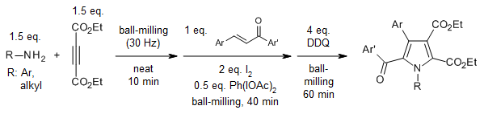
The combination of I₂/PhI(OAc)₂ promotes an efficient and practical one-pot reaction of amines with alkyne esters and chalcones under solvent-free ball-milling conditions to afford a variety of polysubstituted trans-2,3-dihydropyrroles in good yields. This protocol furnishes the corresponding pyrroles with the addition of DDQ as oxidant in a subsequent step.
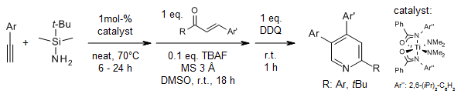
Regioselective hydroamination of alkynes with N-silylamine using a bis(amidate)bis(amido) titanium(IV) precatalyst, addition of α,β-unsaturated carbonyls to the crude mixture followed by oxidation affords 47 examples of pyridines in good yields containing variable substitution patterns, including pharmaceutically relevant 2,4,5-trisubstituted pyridines.
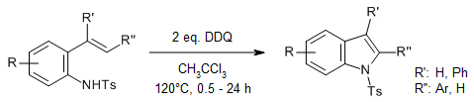
The use of DDQ as an oxidant enables an effective metal-free C-H amination of N-Ts-2-alkenylanilines to afford a diverse range of substituted indoles. This operationally simple and robust protocol obviates the need of expensive transition-metal catalysts, and offers a broad substrate scope. A mechanism involving a radical cation generated by SET and a migratorial process via a phenonium ion intermediate is proposed.
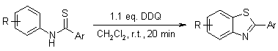
Various benzothiazoles were synthesized by the intramolecular cyclization of thioformanilides using 2,6-dichloro-3,5-dicyano-1,4-benzoquinone (DDQ) in dichloromethane at ambient temperature in high yields.
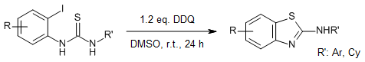
A transition-metal-free, DDQ-mediated method enables the intramolecular S-arylation of o-halobenzothiaoureas to yield 2-aminobenzothiazole derivatives. The reactions are performed at room temperature under base-free conditions with very good yields.
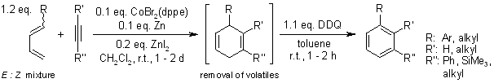
A cobalt-catalyzed neutral Diels-Alder reaction of dienes derived from aldehydes with terminal and internal alkynes, and DDQ oxidation of the dihydroaromatic intermediates leads to regiochemically enriched biphenyl, terphenyl, and silyl-functionalized benzene derivatives in good to excellent yields.
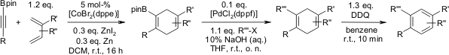
The cobalt-catalyzed Diels-Alder reaction of alkynyl pinacol boronic esters with various dienes generates cycloadducts in very good regioselectivity. A reaction sequence (Diels-Alder reaction, Suzuki coupling, DDQ oxidation) was successfully performed as a one pot operation without isolation of the intermediates.
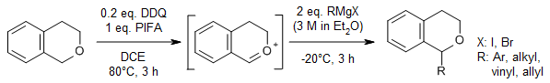
The use of [bis(trifluoroacetoxy)iodo]benzene as stoichiometric oxidant and 2,3-dichloro-5,6-dicyano-1,4-benzoquinone as organocatalyst enables a convenient oxidation of isochromans. A further reaction with Grignard reagents or amides affords the corresponding isochroman derivatives.
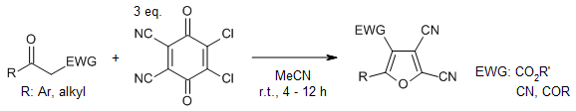
A facile oxidative coupling of α-carbonyl radicals to 2,3-dichloro-5,6-dicyanobenzoquinone (DDQ) enables the synthesis of 2,3-dicyanofurans and thiophenes from readily available β-diketones, simple ketones, and β-keto thioamides in very good yield. Mechanistic investigations revealed that a radical process and a water-promoted C-C bond cleavage could be involved in this transformation.
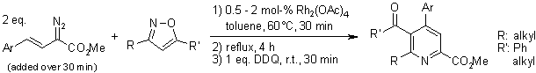
A concise one-pot synthesis of highly functionalized pyridines involves a formal insertion of rhodium vinylcarbenoids derived from diazo compounds across the N-O bond of isoxazoles. Upon heating, the insertion products undergo a rearrangement to give 1,4-dihydropyridines. DDQ oxidation then affords the corresponding pyridines in good yield.
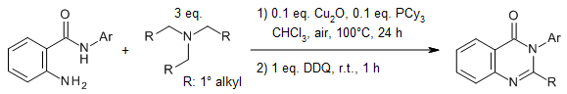
A copper-catalyzed tandem reaction of 2-aminobenzamides with tertiary amines provides quinazolinone derivatives. A broad range of substrates reacted under the standard conditions to give the corresponding quinazolinone derivatives in good yields.
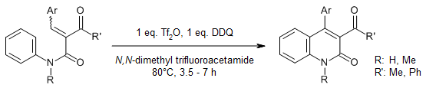
A facile and efficient intramolecular cyclization of readily available N-aryl cinnamides is promoted by triflic anhydride in N,N-dimethyl trifluoroacetamide (DTA) under mild conditions to provide polysubstituted quinolin-2(1H)-ones.
Part-2
2,3-Dichloro-5,6-dicyano-1,4-benzoquinone (DDQ) is useful for the dehydrogenation of alcohols, phenols, and steroid ketones in organic chemistry. DDQ decomposes in water, but is stable in aqueous mineral acid.
Reactions
The reagent removes pairs of H atoms from organic molecules. The stoichiometry of its action is illustrated by the conversion of tetralin to naphthalene:
2 C₆Cl₂(CN)₂O₂ + C₁₀H₁₂ → 2 C₆Cl₂(CN)₂(OH)₂ + C₁₀H₈
The resulting hydroquinone is poorly soluble in typical reaction solvents (dioxane, benzene, alkanes), which facilitates workup.
Solutions of DDQ in benzene are red, due to the formation of a charge-transfer complex.

Dehydrogenation
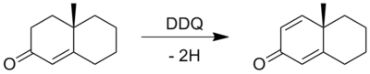

Aromatization
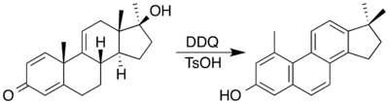

Cross-Dehydrogenative Coupling
