Biosynthesis of Estradiol from Cholesterol

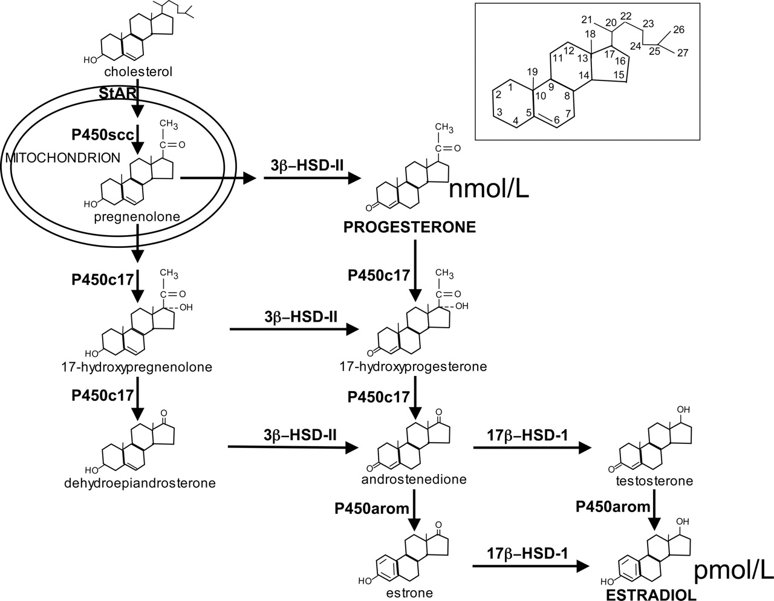

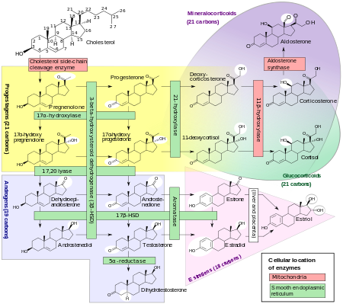

Sites
http://pharmrev.aspetjournals.org/content/57/3/359
https://en.wikipedia.org/wiki/Estradiol

